MetaData Upload

1. <https://app.pinata.cloud/pinmanager>

create account and go into this url

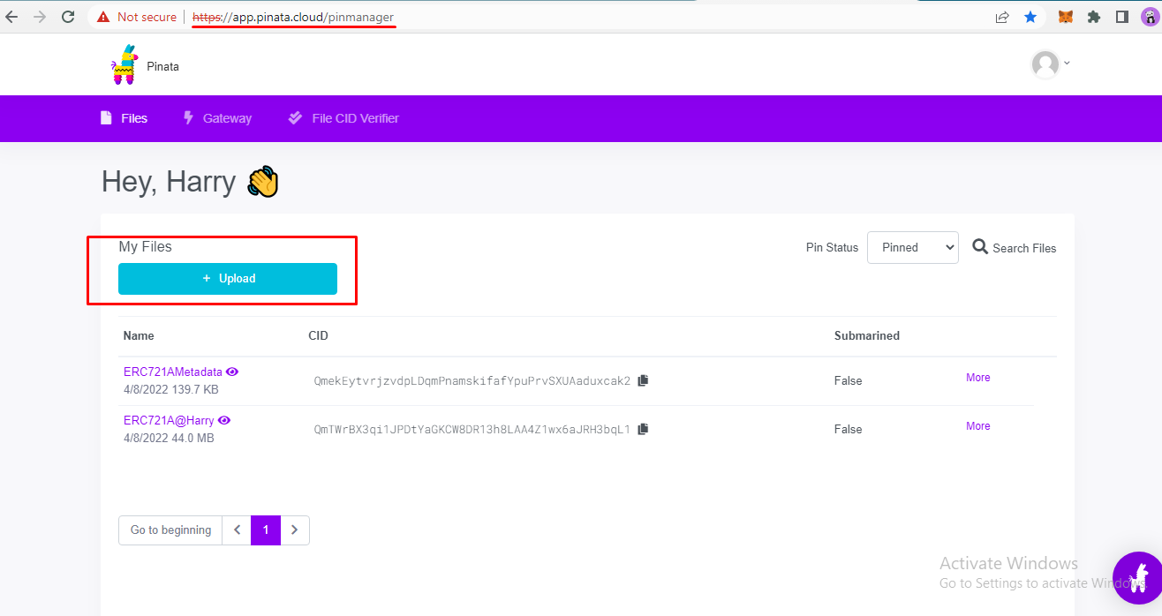

1. Click “+ Upload” button and select upload type (in our case, Folder)

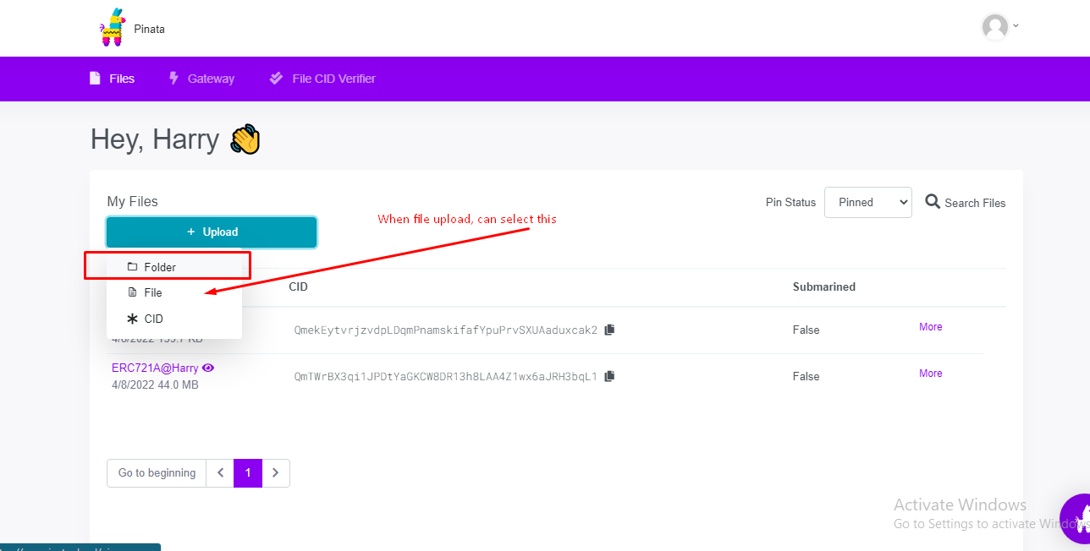

1. In modal, Select folder or file name(it is not important) and wait for uploading.

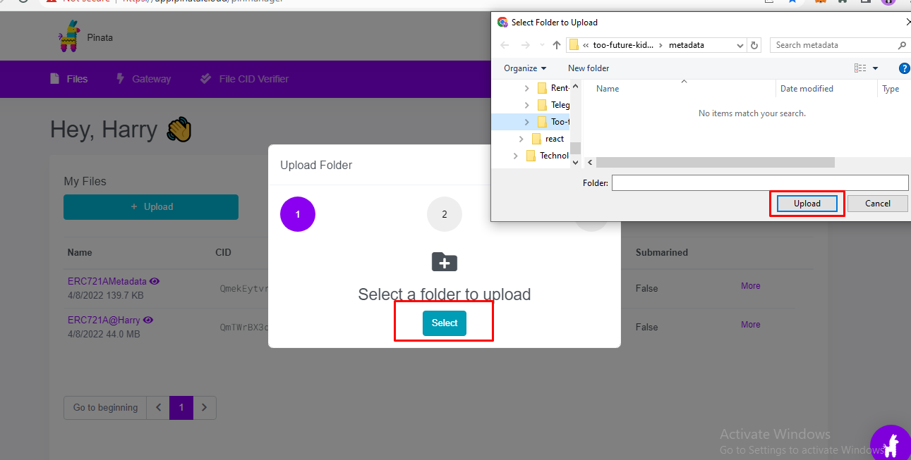

1. In last, you can see your result in table

